SERVER SIDE MODULE

CONTENTS
This module has the following files:
- MODULE_SERVER_SIDE.docx
- MODULE_SERVER_SIDE.pdf
- MODULE_SERVER_SIDE_MEDIA.zip

INTRODUCTION
In this module, you are asked to create a social media website called “Facegram” where in the website a user can see other user's posts by following the user. Users can also register as a private account so other users who are not following could not see posts. The detailed description and tools that you can use will be described below.

DESCRIPTION OF PROJECT AND TASKS
This module is divided into 2 phases. In the first phase, you will create a REST Api then in the second phase you will create a frontend application with the following provided frameworks:
- Laravel (v10.x)
- React (v18.x with react-router and axios)
- Vue (v3.x with vue-router and axios)

Phase 1 - REST API
For all endpoints, the request header as default sets Content-type: application/json, but some endpoints have specified Content-type header so you have to adjust it.

Authentication
You can use sanctum for the token management and it must be valid when placed in the Authorization request header as a Bearer token.
- Register
Endpoint | /api/v1/auth/register
Method | POST
Description | For user to register account
Request | Body:  full_name (required)  bio (required, max 100 chars)  username (required, min 3 chars, unique, only alphanumeric, dot “.” or underscore “_” allowed)  password (required, min 6 chars)  is_private (boolean)
Response  Success | HTTP Status Code: 201  Body:  {  "message": "Register success",  "token": "7|xuPEGo7jtV8IhoE2Mp3am1rwtIpYUTewXBTcH78Af922f116",  "user": {  "full_name": "Budi Budiman",  "bio": "stop dreaming, start doing",  "username": "budi.budiman",  "is_private": true,  "id": 101  }  }
Response  Invalid Field | HTTP Status Code: 422  Body:  {  "message": "Invalid field",  "errors": {  "full_name": [  "The full name field is required."  ],  "username": [  "The username has already been taken."  ],  "password": [  "The password field must be at least 6 characters."  ],  "bio": [  "The bio field is required."  ]  }  }

- Login
Endpoint | /api/v1/auth/login
Method | POST
Description | For user to log into system
Request | Body:  username  password
Response  Success | HTTP Status Code: 200  Body:  {  "message": "Login success",  "token": "2|Qnt2aqHIi0EVwCz3rSH0yiFIKMqey38SdkUZntRvf0e507ff",  "user": {  "id": 1,  "full_name": "John Doe",  "username": "john.doe",  "bio": "The best way to predict the future is to create it.",  "is_private": 0,  "created_at": "2023-10-14T15:04:33.000000Z"  }  }
Response  Failed | HTTP Status Code: 401  Body:  {  "message": "Wrong username or password"  }

- Logout
Endpoint | /api/v1/auth/logout
Method | POST
Description | For user to logout
Request | Headers:  Authorization: Bearer <token>  Body:  username  password
Response  Success | HTTP Status Code: 200  Body:  {  "message": "Logout success"  }
Response  Invalid Token | HTTP Status Code: 401  Body:  {  "message": "Unauthenticated."  }

Post

Create new post
Endpoint | /api/v1/posts
Method | POST
Description | For user to create a post
Request | Headers:  Authorization: Bearer <token>  Content-type: multipart/form-data  Body:  caption (required)  attachments (required, array of image files jpg, jpeg, webp, png or gif)
Response  Success | HTTP Status Code: 201  Body:  {  "message": "Create post success"  }
Response Invalid Field | Body:  {  "message": "Invalid field",  "errors": {  "caption": [  "The caption field is required."  ],  "attachments.0": [  "The attachments.0 field must be a file of type: png, jpg, jpeg, webp."  ]  }  }
Response  Invalid Token | HTTP Status Code: 401  Body:  {  "message": "Unauthenticated."  }

Delete post
Endpoint | /api/v1/posts/:id
Method | DELETE
Description | For user to delete a post
Request | Headers:  Authorization: Bearer <token>
Response  Success | HTTP Status Code: 204
Response Post Not Found | HTTP Status Code: 404  Body:  {  "message": "Post not found"  }
Response Try to delete another user’s post | HTTP Status Code: 403  Body:  {  "message": "Forbidden access"  }
Response  Invalid Token | HTTP Status Code: 401  Body:  {  "message": "Unauthenticated."  }

Get posts
Endpoint | /api/v1/posts
Method | GET
Description | For user to get all posts
Request | Headers:  Authorization: Bearer <token>  Params:  page (integer, minimum 0 and default 0)  size (integer, minimum 1 and default 10)
Response  Success | HTTP Status Code: 200  Body:  {  "page": 0,  "size": 10,  "posts": [  {  "id": 366,  "caption": "Letting my soul wander",  "created_at": "2023-07-26 00:34:10",  "deleted_at": null,  "user": {  "id": 61,  "full_name": "Irving Greenfelder",  "username": "talia94",  "bio": "Success is not final, failure is not fatal: It is the courage to continue that counts.",  "is_private": 0,  "created_at": "2023-10-18 19:16:53"  },  "attachments": [  {  "id": 750,  "storage_path": "posts/652fc6284eb76.jpg"  }  ]  },  ….  ]  }
Response Invalid Params | HTTP Status Code: 422  Body:  {  "message": "Invalid field",  "errors": {  "page": [  "The page field must be at least 0."  ],  "size": [  "The size field must be a number."  ]  }  }
Response Try to delete another user’s post | HTTP Status Code: 403  Body:  {  "message": "Forbidden access"  }
Response  Invalid Token | HTTP Status Code: 401  Body:  {  "message": "Unauthenticated."  }

Following

Follow a user
Endpoint | /api/v1/users/:username/follow
Method | POST
Description | For user to follow another user
Request | Headers:  Authorization: Bearer <token>
Response  Success | HTTP Status Code: 200  Body:  {  "message": "Follow success",  "status": "following" | "requested"  }
Response User not found | HTTP Status Code: 404  Body:  {  "message": "User not found"  }
Response Try to follow own user account | HTTP Status Code: 422  Body:  {  "message": "You are not allowed to follow yourself"  }
Response Already Followed | HTTP Status Code: 422  Body:  {  "message": "You are already followed",  "status": "following" | "requested"  }
Response  Invalid Token | HTTP Status Code: 401  Body:  {  "message": "Unauthenticated."  }

Unfollow a user
Endpoint | /api/v1/users/:username/unfollow
Method | DELETE
Description | For user to unfollow a followed user
Request | Headers:  Authorization: Bearer <token>
Response  Success | HTTP Status Code: 204
Response User not found | HTTP Status Code: 404  Body:  {  "message": "User not found"  }
Response Not Following the User | HTTP Status Code: 422  Body:  {  "message": "You are not following the user"  }
Response  Invalid Token | HTTP Status Code: 401  Body:  {  "message": "Unauthenticated."  }

Get following users
Endpoint | /api/v1/following
Method | GET
Description | For users to get their following users
Request | Headers:  Authorization: Bearer <token>
Response  Success | HTTP Status Code: 200  Body:  {  "following": [  {  "id": 91,  "full_name": "Miss Ayana Russel",  "username": "chartmann",  "bio": "In a world where you can be anything, be kind.",  "is_private": 0,  "created_at": "2023-10-18 19:16:55",  "is_requested": true | false  },  ….  ]  }
Response User not found | HTTP Status Code: 404  Body:  {  "message": "User not found"  }
Response  Invalid Token | HTTP Status Code: 401  Body:  {  "message": "Unauthenticated."  }

Followers

Accept follow request
Endpoint | /api/v1/users/:username/accept
Method | PUT
Description | For users to get their following users
Request | Headers:  Authorization: Bearer <token>
Response  Success | HTTP Status Code: 200  Body:  {  "message": "Follow request accepted"  }
Response User not found | HTTP Status Code: 404  Body:  {  "message": "User not found"  }
Response Already Accepted | HTTP Status Code: 422  Body:  {  "message": "Follow request is already accepted"  }
Response User Not Following | HTTP Status Code: 422  Body:  {  "message": "The user is not following you"  }
Response  Invalid Token | HTTP Status Code: 401  Body:  {  "message": "Unauthenticated."  }

Get follower users
Endpoint | /api/v1/users/:username/followers
Method | GET
Description | For users to get their following users
Request | Headers:  Authorization: Bearer <token>
Response  Success | HTTP Status Code: 200  Body:  {  "followers": [  {  "id": 91,  "full_name": "Miss Ayana Russel",  "username": "chartmann",  "bio": "In a world where you can be anything, be kind.",  "is_private": 0,  "created_at": "2023-10-18 19:16:55",  "is_requested": true | false  },  ….  ]  }
Response User not found | HTTP Status Code: 404  Body:  {  "message": "User not found"  }
Response  Invalid Token | HTTP Status Code: 401  Body:  {  "message": "Unauthenticated."  }

User

Get users
Endpoint | /api/v1/users
Method | GET
Description | Get all users that are not followed by logged in users. Logged in users should be hidden in the list.
Request | Headers:  Authorization: Bearer <token>
Response  Success | HTTP Status Code: 200  Body:  {  "users": [  {  "id": 1,  "full_name": "John Doe",  "username": "john.doe",  "bio": "The best way to predict the future is to create it.",  "is_private": 0,  "created_at": "2023-10-14T15:04:33.000000Z",  "updated_at": "2023-10-14T15:04:33.000000Z"  },  ….  ]  }
Response  Invalid Token | HTTP Status Code: 401  Body:  {  "message": "Unauthenticated."  }

Get detail user
Endpoint | /api/v1/users/:username
Method | GET
Description | For users to get detailed user data. Field posts should be hidden if the user is a private user and the follow status is not following or is requested.
Request | Headers:  Authorization: Bearer <token>
Response  Success | HTTP Status Code: 200  Body:  {  "id": 2,  "full_name": "Richard Roe",  "username": "richard.roe",  "bio": "Leave a little sparkle wherever you go.",  "is_private": 1,  "created_at": "2023-10-18 19:16:50",  "is_your_account": false,  "following_status": "not-following" | "requested" | “following”,  "posts_count": 6,  "followers_count": 20,  "following_count": 18,  "posts": [  {  "id": 7,  "caption": "Blissfully lost in the beauty of the moment.",  "created_at": "2014-08-26 10:42:31",  "deleted_at": null,  "attachments": [  {  "id": 13,  "storage_path": "posts/shutterstock_1464930743-scaled.webp"  },  ….  ]  },  ….  ]  }
Response  Invalid Token | HTTP Status Code: 401  Body:  {  "message": "Unauthenticated."  }
Response User not found | HTTP Status Code: 404  Body:  {  "message": "User not found"  }
Response  Invalid Token | HTTP Status Code: 401  Body:  {  "message": "Unauthenticated."  }

Phase 2 - Frontend Development
Template HTML is provided. You are required to use the template and you are recommended to modify the template design without affecting the functionality of the frontend.
Page | Description Tasks
General | - Document title should be reflected to the current page  - Display username and logout button on the navbar after login success  - Clicking username will go to logged in user profile page  - User can log out after clicking logout button on the navbar
Register | - If user logged in, the page will be redirected to own user profile page  - User can register account  - If register fails, display all of errors message  - If logged in user try to access this page, the page should be redirected to own user profile page
Login | - If user logged in, the page will be redirected to own user profile page  - User can login with existing credentials  - If login fails, display all of errors message  - If logged in user try to access this page, the page should be redirected to own user profile page
Homepage | - If user not logged in, the page will be redirected to login page  News Feed section  - Display following user’s posts and own posts sorted by newest post on the newsfeed section  - When page loads, display only first 10 newest posts  - If the vertical scroll is stuck at the bottom, load the next 7 posts  Explore people section  - Display all users that are not followed by the logged in user  - Clicking on username will go to that user profile page  Follow requests section (for private account)  - Display follow request users  - The logged in user can accept/approve a follow request  - If the logged in user is not a private account or there is no any follow request, hide this section
User profile | Page requirements:  - If user not logged in, the page will be redirected to login page  User information:  - See profile (full_name, username, bio)  - See posts list and count  - See followers list and count  - See following list and count  Follow/unfollow:  - User can follow another user  - User can unfollow a followed user  Posts section:  - Display user’s posts where the visited user is not a private account or following account  - Users can delete their posts  - Display “The account is private” if logged in user is not following the visited private user profile page
Create new post | - If user not logged in, the page will be redirected to login page  - User can create new post with following fields:  - caption (text, required)  - attachments (file, can attach multiple files)  - If create new post fails, display all of errors message

ER DIAGRAM
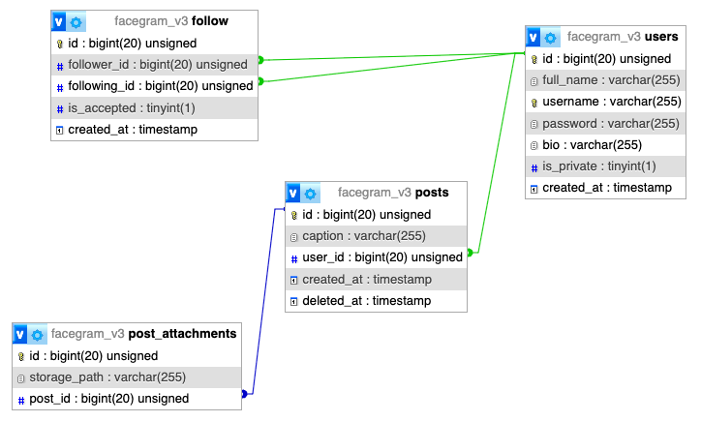

ADDITIONAL EXPLANATION
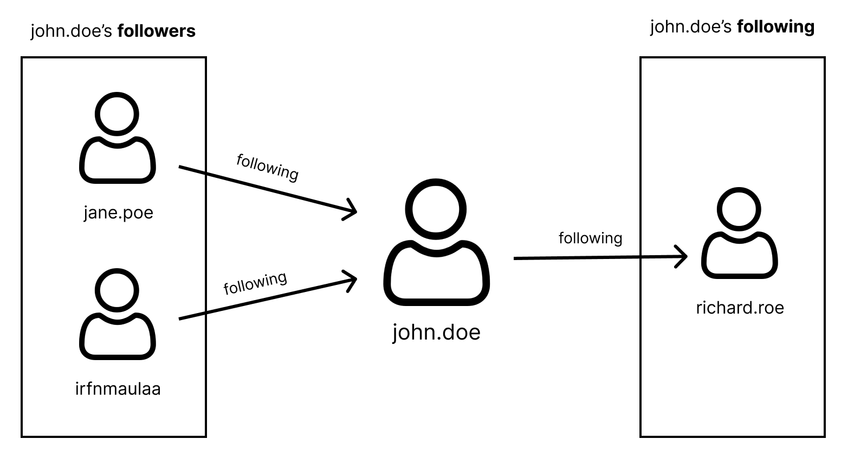

MEDIA FILES
- Frameworks (laravel, react and vue)
- SQL File (structure and records. allowed to modify)
- Postman collection
- Template HTML (based on bootstrap v5.3)

INSTRUCTION FOR COMPETITORS
- Database (db-dump.sql) and ER diagram (db-diagram.pdf) should be exported and saved under the root folder <host>/XX_SERVER_MODULE
- REST Api should be reached on <host>/XX_SERVER_MODULE/BACKEND where xx is PC number.
No port and no /public suffix path.
- Frontend app should be reached on <host>/XX_SERVER_MODULE/FRONTEND where xx is PC number.
No port allowed
- Zip XX_SERVER_MODULE and submit to the submission page. Make sure to exclude vendor and node_modules folder when zipping files.

